**Experiment: 1**

1. **Aim:** Input a Rupees and prints its value converted into Dollar.

**Software:** Dev C++

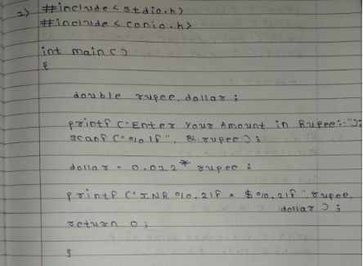**Code:**

**Output:**

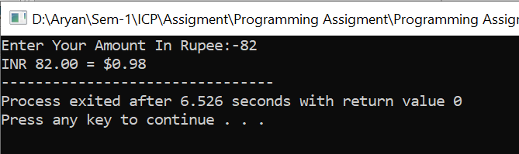

**Experiment: 2**

**Aim:** Input two numbers and prints its Addition, Subtraction, Multiplication, and Division.

**Software:** Dev C++

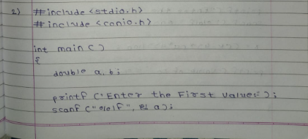**Code:**

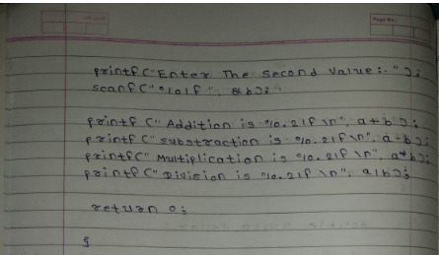

**Output:**

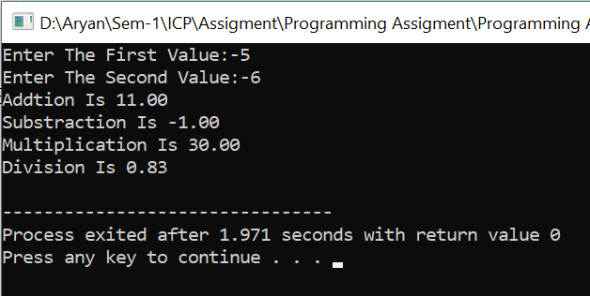

**Experiment: 3**

**Aim:**  Verify the formula x=((k-4)*(a*4))/100

**Software:** Dev C++

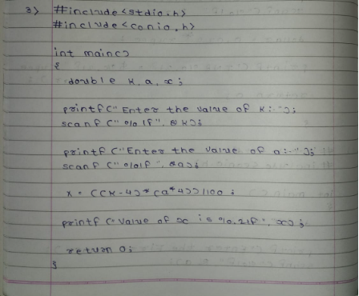**Code:-**

**Output:**

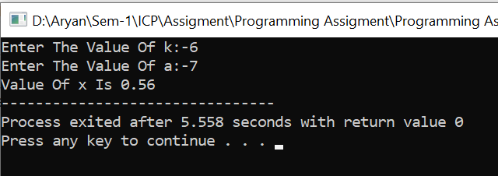

**Experiment: 4**

**Aim:**  Write down a program to implement Left and Right shift operator (shifting should be by 3 ).

**Software:** Dev C++

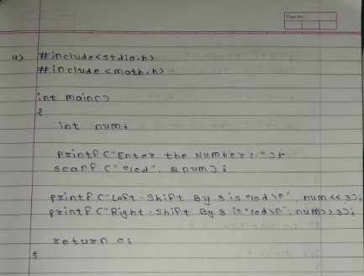**Code:-**

**Output:-**

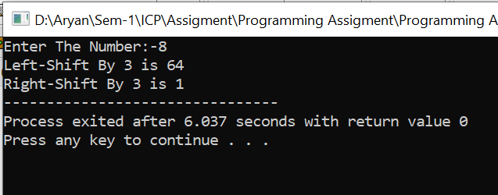

**Experiment: 5**

**Aim:-**  Verify the formula t=((v+s)+(l-m)*l)

**Software:-** Dev C++

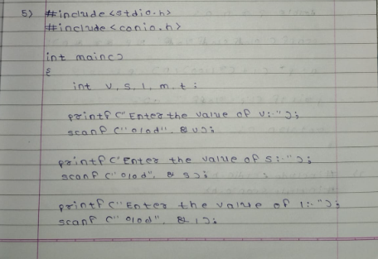**Code:-**

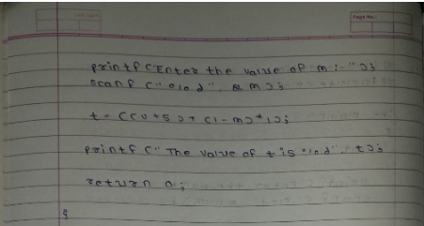

**Output:-**

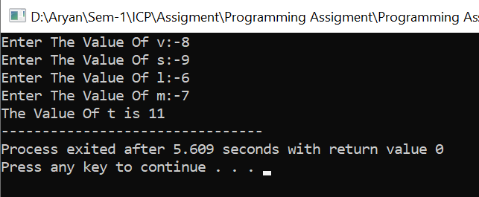

**Experiment: 6**

**Aim:-**  Verify the formula a=p*(1+(r/100)/n)-p

**Software:-** Dev C++

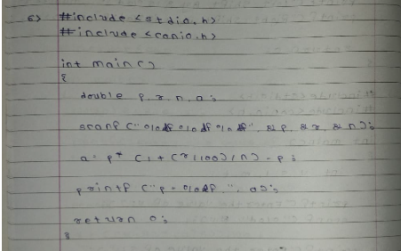**Code:-**

**Output:-**

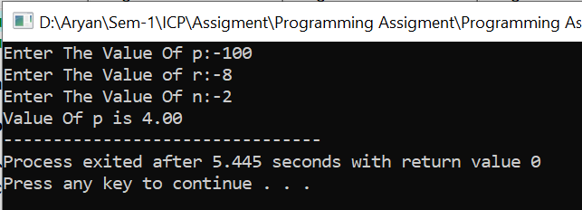

**Experiment: 7**

**Aim:-**  Verify the formula s=((4*a+c)-2*a*b)/100

**Software:-** Dev C++

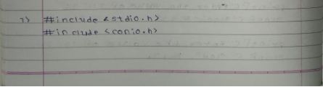**Code:-**

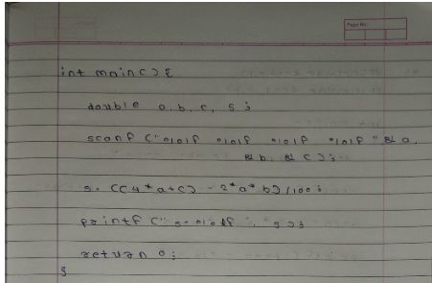

**Output:-**

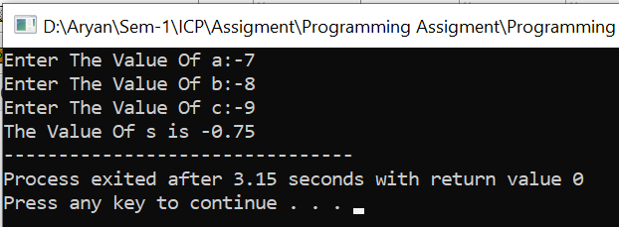

**Experiment: 8**

**Aim:-**  Verify the formula l=(c+d)*(g+h).

**Software:-** Dev C++

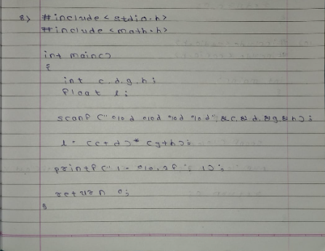**Code:-**

**Output:-**

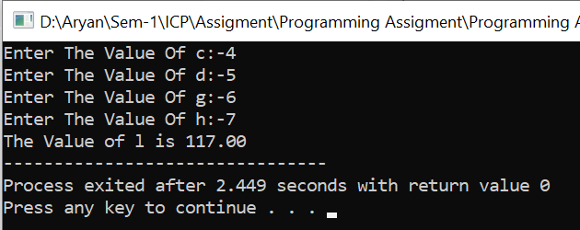

**Experiment: 9**

**Aim:-**  Write a program to find out the area of a right-angle triangle.

**Software:-** Dev C++

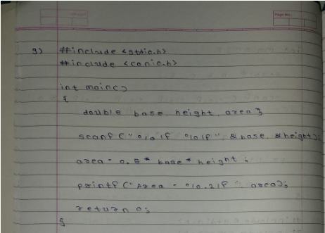**Code:-**

**Output:-**

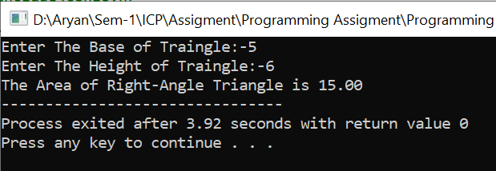

**Experiment: 10**

**Aim:-**  Verify the formula t=((v+s)+(l-m)*l)

**Software:-** Dev C++

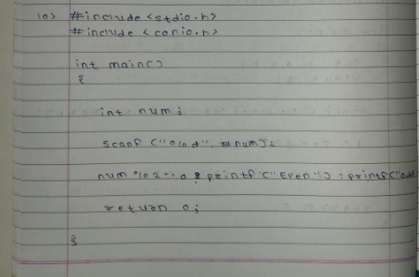**Code:-**

**Output:-**

